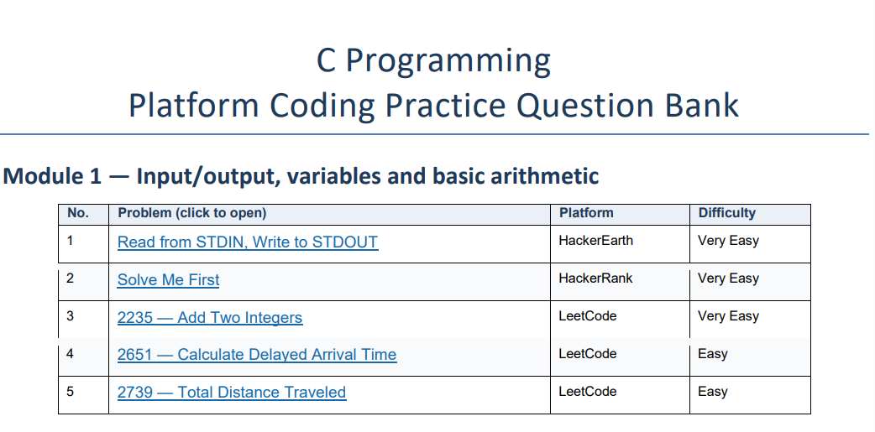

- Read from STDIN, Write to STDOUT https://www.hackerearth.com/practice/basic-programming/input-output/basics-of-input-output/practice-problems/algorithm/io-exercise/
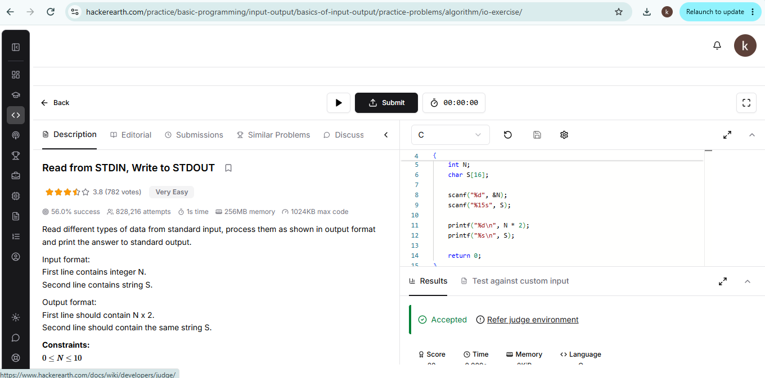

- Solve me first https://www.hackerrank.com/challenges/solve-me-first/problem
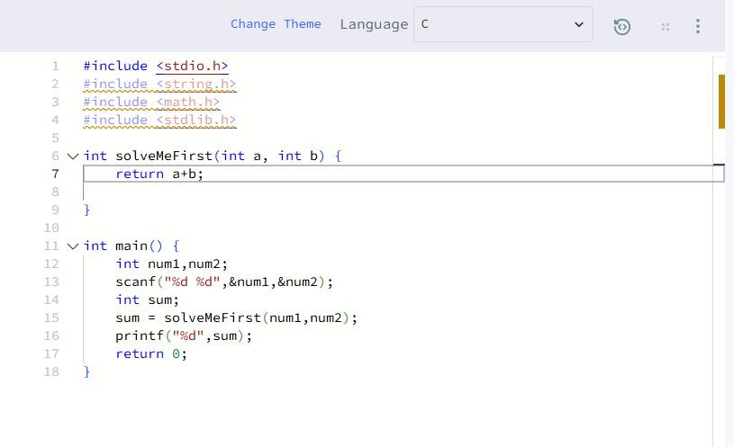

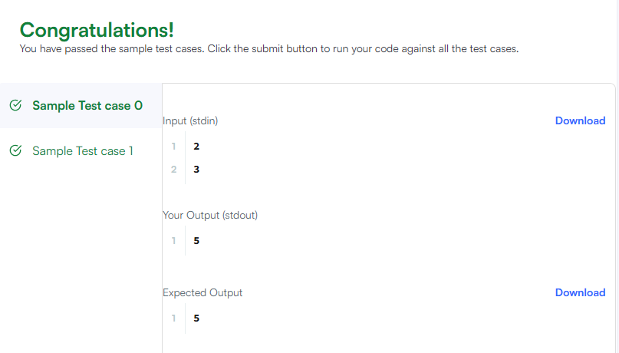

- Add two integers https://leetcode.com/problems/add-two-integers/submissions/2191435525/
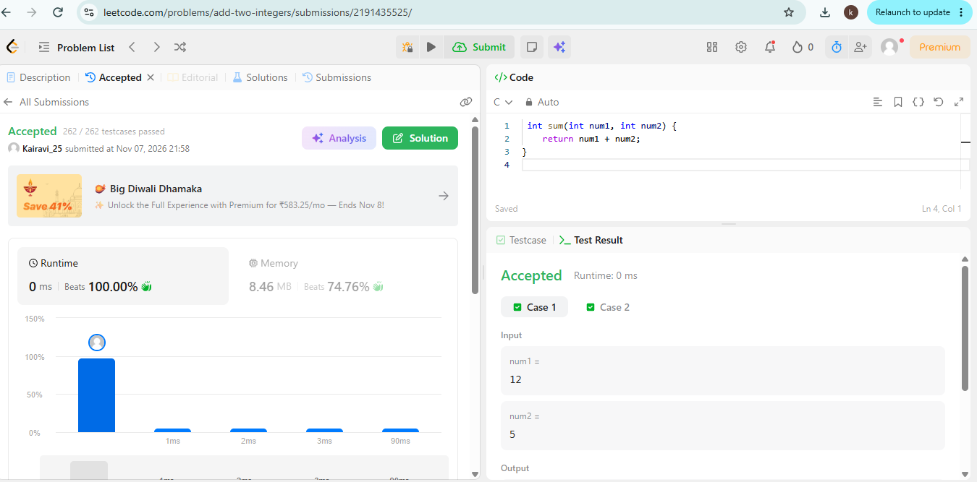

- Calculate Delayed Arrival Time https://leetcode.com/problems/calculate-delayed-arrival-time/submissions/2191445707/
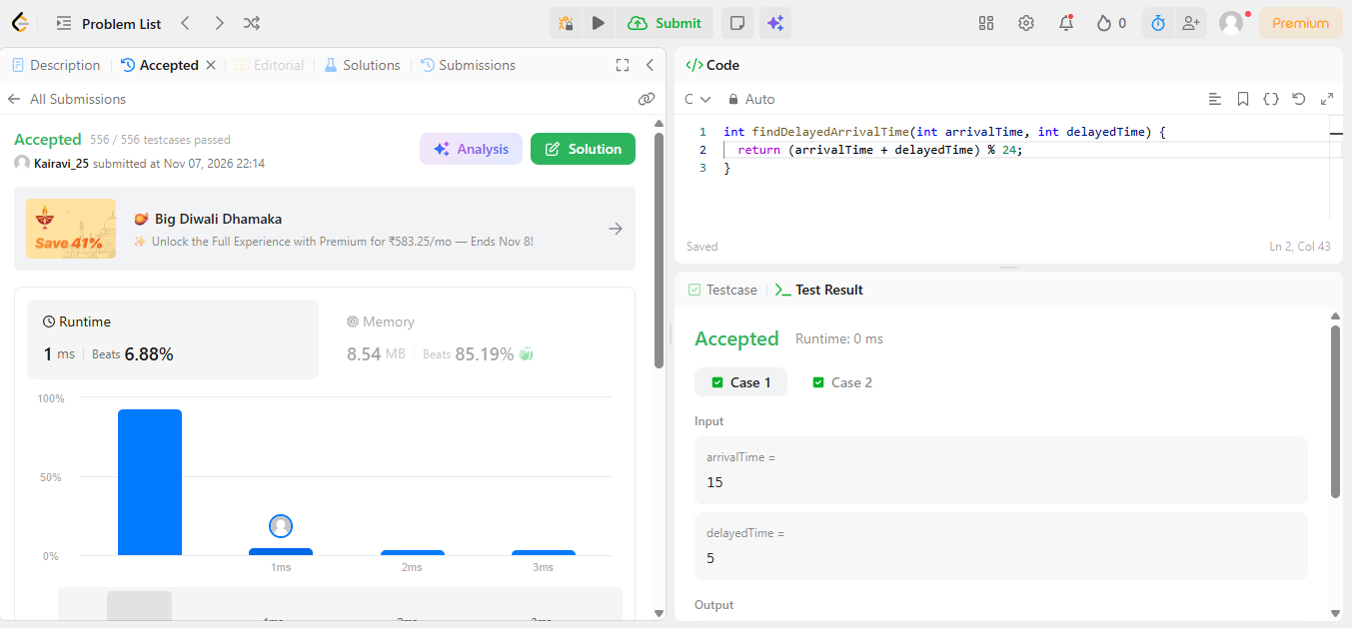

- Total Distance Travelled https://leetcode.com/problems/total-distance-traveled/submissions/2191462300/


